

Global Dashboard

USER MANUAL GUIDELINES

2018

**Revision History**

|  |  |  |  |  |  |  |
| --- | --- | --- | --- | --- | --- | --- |
| **No.** | **Version** | **Release Date** | **Author** | **Reviewer** | **Revised Sections** | **Remarks** |
| 1 | 1 |  | Saurabh Goel |  |  |  |
|  |  |  |  |  |  |  |
|  |  |  |  |  |  |  |
|  |  |  |  |  |  |  |

|  |
| --- |
|  |

Table of Contents

1. Introduction 3

1.1 Objective of the Manual 3

1.2 Intended Audience 3

1.3 Organization of the manual 3

1.4 Glossary of Terms 4

1.5 Systems Requirements 4

2. Getting Started in Global dashboard Platform 5

2.1 Login 5

2.2 Home Page 6

2.3 Log Out 7

3. Live feeds 7

4. Live Summary 8

4.1 – Overall View 8

4.2 - RL Client View 8

4.3 - Physician Client View 9

5. Scoring Status 11

5.1 - Pre Bill 11

5.2 - Post Bill 13

5.3 - Physician Scoring 13

5.4 - Scoring Time 14

6. Analysis 15

1. Introduction

Global dashboard is basically used by Admin user, which is internal to the system. This dashboard keeps track of all the activity of both Revenue leakage application as well as Physician recon application. This is the single dashboard to check the live status of all the clients for both RL and PR systems. For example

* Live summary
* Scoring status and scoring time
* All client wise account status like (Completed, Reviewed, Hit account and amount found)
* Client view based on (Facility and Auditor)
* Analysis of data

Some of the benefits of using this application are listed below.

* Find charges more accurately
* Enhances productivity
* Accurate and Efficient
* Software requires no IT investment

It is very user friendly and it is an easy system to navigate.

1.1 Objective of the Manual

The objective of this manual is to provide assistance to the users ensuring effective use of the features and functionalities of the Revenue Leakage Platform application. The manual provides step-by-step descriptions of the functionality within the Dashboard, Pre-bill Account List, Post-Bill Account List pages, Edit submitted accounts, Coding Edits and Submitted Coding Edits.

## 1.2 Intended Audience

The intended users of this manual are:

* Auditors
* Supervisors

Access to the application is through the role and per­mission privileges.

## 1.3 Organization of the manual

The Revenue Leakage User Guide includes the following chapters:

* Dashboard
* Pre bill Account List
* Post Bill Account List
* Confirmed Charges
* Edit Submitted Charges
* CCI Edits
* Submitted CCI Edits

## 1.4 Glossary of Terms

* Live Summary
* Scoring Status
* Analysis

## 1.5 Systems Requirements

In order to use the Revenue Leakage application all end users must access it through a web browser. Supported web browsers are Firefox, Chrome, Internet Explorer, Version8 or later. In addition, the only end users who are permitted to access the Revenue Leakage Platform application are those that are authorized. (Describe Browser Settings)

# Getting Started in Global dashboard Platform

## 2.1Login

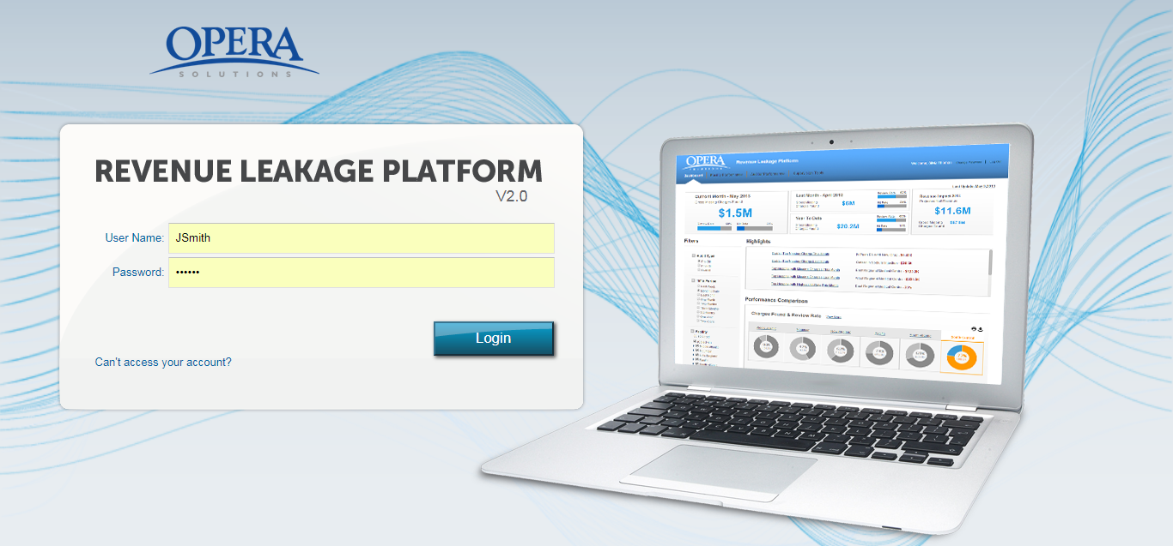

Figure 1: Login screen

**Step 1:** The applicationcan be accessed by entering the following URL into the   
 address box:

_________________________________________

**Step 2:** Enter your **Username** and **Password**.

**Step 3:** Click **Sign In**

**Step 4:** After entering the correct username and password, user is redirected to the   
 Home page of Revenue Leakage Platform.

## 2.2 Home Page

The Home page has following four tabs. By default, **Dashboard** tab is selected.

1. **Live Summary:** The page provides a snapshot of all theclients for both Revenue leakage platform and Physician Recon. This is showing the account status based on completed/Reviewed/Amount found and Hit accounts.It is showing overall view and client specific view also.
2. **Scoring Status:** It shows the scoring status of both the platform (RL & Physician). It is showing all the scoring process status with start time/status/ completions/ account published.
3. **Analysis:** This screen is showing a client specific dashboard view. You are able to view details like the Review Rate and the Missing Charges of various hospitals based on the filter criterion selected.

## 2.3 Log Out

You can log out of the application from any screen by clicking on the **Log Out** link from the   
 header bar.

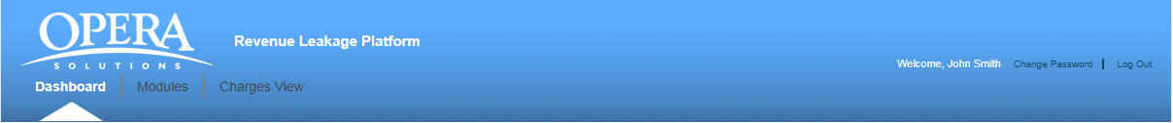

Figure 2: Logout Screen

You are logged out of the application and the Login screen is displayed.

# Live feeds

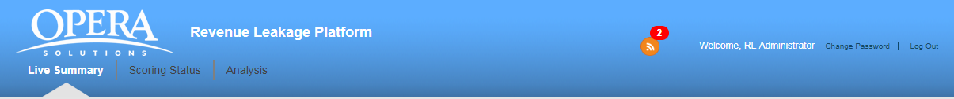

In Header of application we have live feed ticker, it is showing in red colour with number inside that. It is showing that we have 2 un-read feed available.

When we expand that feed ticker it will show the below view.

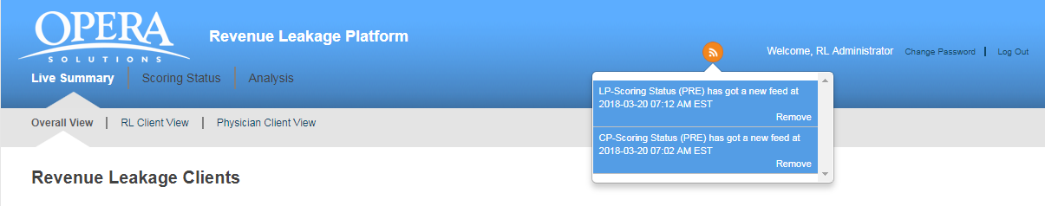

Below colour in feed ticker showing that we have two unread feed. Once we open the pop-up again it will convert in grey colour. Blue colour represent that we have unread feed and grey colour represent the already read feed. Red colour number represent that unread feed available and will go after open the pop-up ticker.

# Live Summary

* Overall View
* RL Client View
* Physician Client view

## 4.1 – Overall View

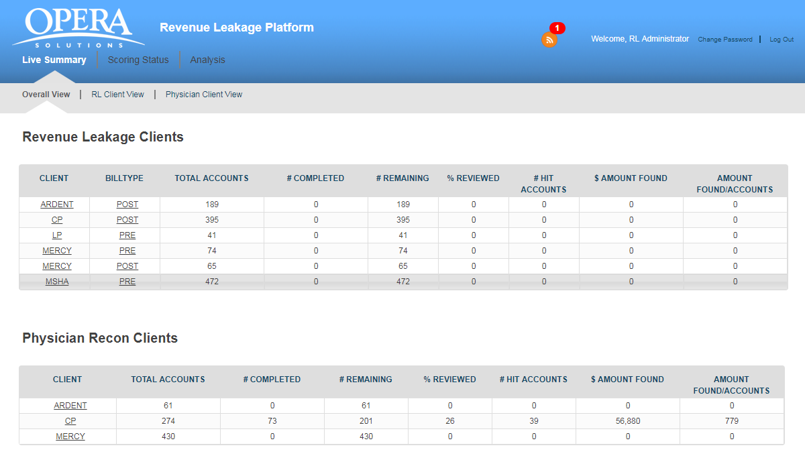

## 4.2 - RL Client View

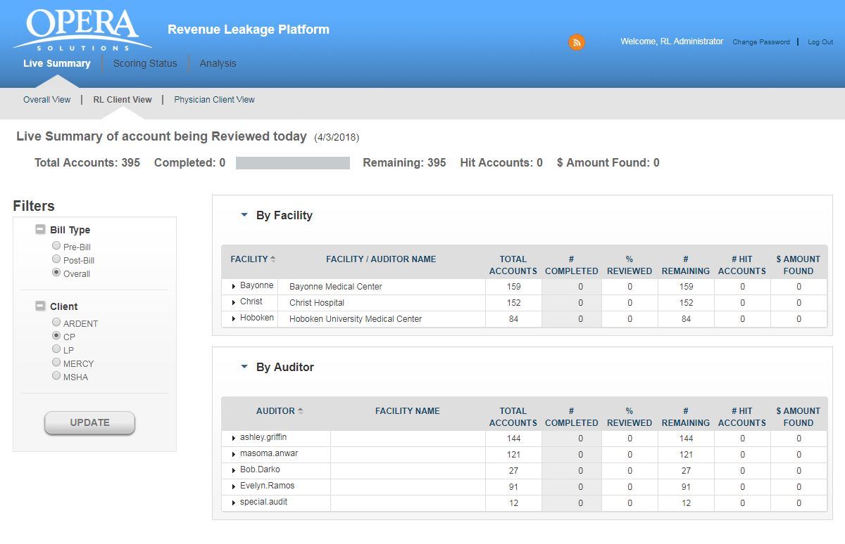

## 4.3 - Physician Client View

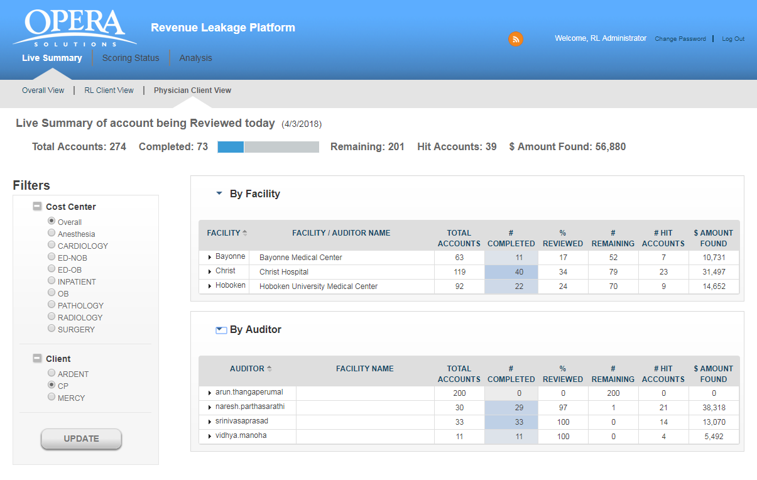

# Scoring Status

* Pre Bill
* Post Bill
* Physician Scoring
* Scoring Time

## 5.1 - Pre Bill

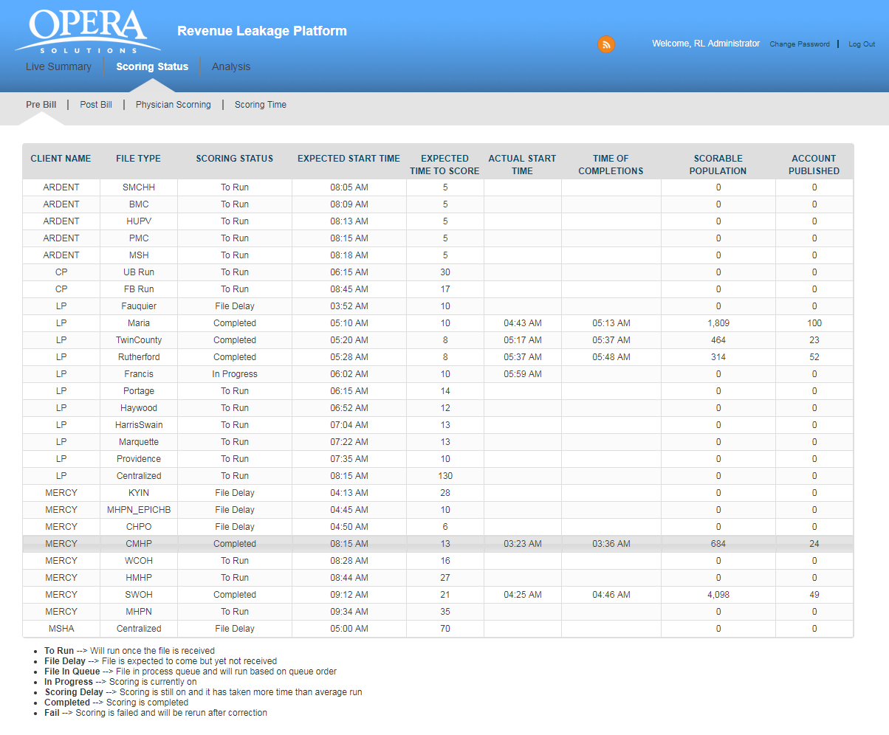

## 5.2 - Post Bill

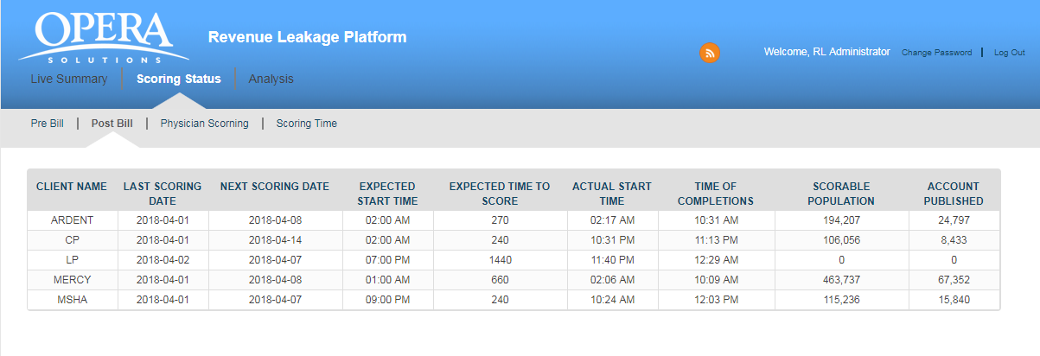

## 5.3 - Physician Scoring

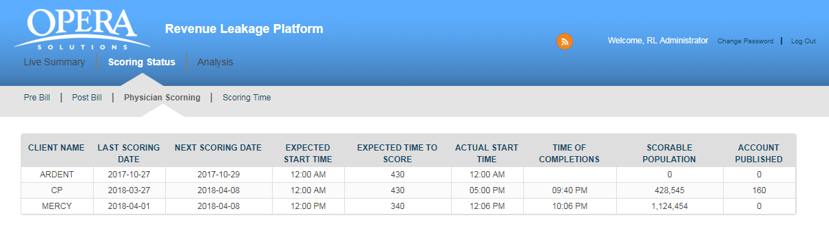

## 5.4 - Scoring Time

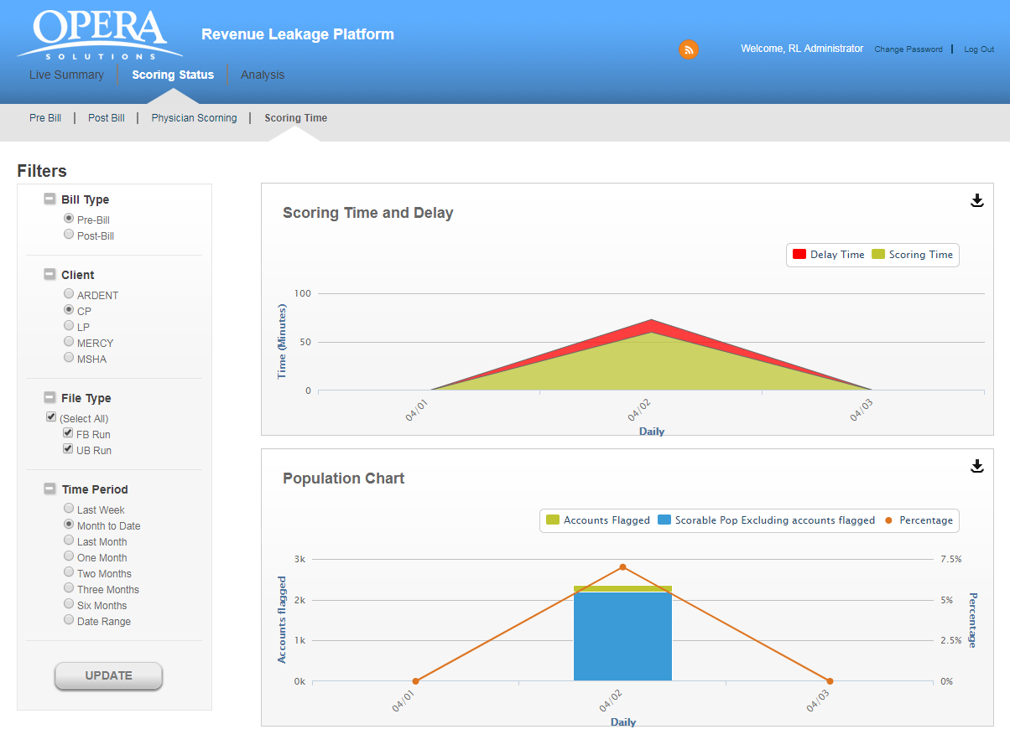

# Analysis

